Online Food Ordering Behaviour Analysis
Oct 28, 2026
Online Food Ordering Behaviour Analysis | DV Mini Project Report
I002 - Param Agarwal
I023 - Hemaang Gaur
I038 - Brandon Laurantes
GitHub repository: https://github.com/paramagarwal216-commits/Preditive_modeling
Live web app: https://paramagarwal216-commits.github.io/Preditive_modeling/

1. Introduction
Online food delivery apps have changed how people in Indian cities eat. Knowing who orders food online, and which personal traits go with it, helps restaurants and delivery platforms target offers and plan their service.
Online Food Ordering Behaviour Analysis is a data visualisation and prediction project built on a Kaggle survey of 388 people in Bangalore, 285 after cleaning. It has three parts: a five-page Microsoft Power BI report, an interactive web dashboard built with React and FastAPI, and three machine-learning models (Logistic Regression, Random Forest and XGBoost) that estimate whether a respondent answers Yes to ordering food online. Slicers and chart clicks filter every visual by gender, occupation, customer type, monthly income and other traits.

2. Problem Statement
Raw survey data is difficult to interpret directly. The file holds 14 columns, 103 duplicate rows and a hidden copy of the answer column, and a single overall percentage hides large differences between groups of people. The project aims to clean the survey, measure how the share of Yes answers varies across customer groups, test which of those differences are statistically real, check whether a model can predict the answer from seven personal details better than guessing, and present the results in interactive dashboards that anyone can explore.

3. Objectives
- Clean the survey by removing exact duplicates and the column that copies the answer.
- Measure the overall Yes rate and the Yes rate within each group of respondents.
- Test which of seven personal traits are linked to the answer, correcting for multiple tests.
- Train three prediction models and compare them fairly against a majority-class baseline.
- Show where respondents live on a map by pin code.
- Present the results in an interactive Power BI report and a web dashboard.

4. Dataset Description and Preparation
The source is onlinefoods.csv from Kaggle (Online Food Ordering Dataset), with 388 rows and 14 columns. The columns describe each respondent's age, gender, marital status, occupation, monthly income, educational qualifications, family size and customer type; their location (latitude, longitude and pin code); the answer to the online-ordering question (Output); their feedback after ordering; and an unnamed final column.
Preparation stage | Rows
Raw survey file | 388
Exact duplicates removed (103 rows) | 285
Rows with missing values removed (none found) | 285
Unnamed 14th column dropped (identical to Output on 100% of rows) | 285 rows, 13 columns

The final dataset contains 285 respondents aged 18 to 33 (average 24.7, median 24): 164 male and 121 female; 189 single, 87 married and 9 who preferred not to say. Students are the largest group (144), followed by employees (94), self-employed people (38) and housewives (9); 131 respondents have no income. 217 respondents (76.1%) answered Yes and 231 (81.1%) gave positive feedback. They live in 77 different pin codes, the largest being 560009 with 22 respondents.
Only seven columns are used as model inputs: Age, Family size, Gender, Marital Status, Occupation, Monthly Income and Educational Qualifications. Feedback is recorded after ordering, so it appears in charts but is never used to predict. Location columns are used only on the map, and Customer Type is shown for description only.
Five helper columns were added during export (export_data.py) and loaded into Power BI:
- Says Yes: 1 if Output is Yes, otherwise 0; summed to count Yes answers.
- Positive Feedback: 1 if Feedback is Positive, otherwise 0.
- Age Band: groups age into three-year bands, from 18–20 to 33–35.
- Income Order and Education Order: sort keys so income bands and education levels appear in their natural order instead of alphabetically.

5. Methodology and Dashboard Design
The work runs in two stages. First, Python (pandas and scikit-learn) cleans the data, runs the statistical tests and trains the models, and export_data.py writes seven CSV files: respondents, model scores, fold scores, feature importance, confusion matrices, association tests and a data dictionary. Second, Power BI loads these files through Power Query, using a DataFolder parameter so the project can be moved, and types each column.
Each model is a single scikit-learn pipeline, so category encoding is learned inside each training fold only. Scores come from stratified 5-fold cross-validation repeated 10 times (50 held-out folds), with hyperparameters tuned by a 3-fold randomized search inside each training fold. Each metric is reported as a mean with a 95% interval, next to a baseline that always predicts Yes. Differences between groups are tested with the chi-square test (2 × 2 tables) or Fisher's exact test with Monte Carlo sampling (larger tables), and the p-values are Holm-corrected because seven traits are tested.
Eight DAX measures drive the report:
Measure | DAX logic | Purpose
Respondents | COUNTROWS of Respondents | Number of respondents in the current filter
Say Yes | SUM of Says Yes | Number who answered Yes
Yes Rate | Say Yes ÷ Respondents | Share who answered Yes
Positive Feedback Rate | Positive Feedback ÷ Respondents | Share who gave positive feedback
Average Age | AVERAGE of Age | Typical age in the current filter
Yes Rate vs All | Yes Rate − Yes Rate over ALL(Respondents) | How far a group is above or below everyone
ROC-AUC Score | Mean ROC-AUC where Metric = "ROC-AUC" | Ranks the models
Predictions | SUM of Confusion[Count] | Fills the confusion matrices

The report has five pages of 1280 × 720:
- 1. Dataset overview: slicers for gender, occupation, customer type and monthly income; KPI cards for respondents, Yes rate, positive feedback and average age; donut charts for Output and marital status; a bar chart of respondents by occupation; a column chart of Yes rate by monthly income; and a combo chart of respondents and Yes rate by age band.
- 2. Who says Yes: bar charts of Yes rate by occupation, marital status and education; a column chart of Yes rate by family size; and a table of the seven association tests with Holm-corrected p-values.
- 3. Geography: a scatter map of pin codes by average latitude and longitude, with bubbles sized by respondents, and a table of pin codes with respondents and Yes rate.
- 4. Model results: a bar chart of ROC-AUC by model, a matrix of all metrics, a line chart of ROC-AUC across the 50 folds, feature-importance bars and a confusion matrix for each model.
- 5. Data dictionary: a table of every column with its type, role, missing values, levels and notes.
The same analysis is also available as a seven-page web dashboard (React, ECharts and FastAPI), including a predictor that explains each prediction step by step.

6. Dashboard Results
The values below are the dashboard outputs with no slicer applied.
KPI cards
Respondents | Say Yes | Yes Rate | Positive Feedback | Average Age
285 | 217 | 76.1% | 81.1% | 24.7

Yes rate by occupation
Occupation | Respondents | Say Yes | Yes Rate
Student | 144 | 126 | 87.5%
Housewife | 9 | 7 | 77.8%
Employee | 94 | 60 | 63.8%
Self-employed | 38 | 24 | 63.2%

Yes rate by monthly income
Monthly income (₹) | Respondents | Say Yes | Yes Rate
No income | 131 | 112 | 85.5%
Below 10,000 | 19 | 15 | 78.9%
10,001 to 25,000 | 36 | 27 | 75.0%
25,001 to 50,000 | 52 | 33 | 63.5%
More than 50,000 | 47 | 30 | 63.8%

Yes rate by age band
Age band | Respondents | Say Yes | Yes Rate
18–20 | 12 | 10 | 83.3%
21–23 | 105 | 93 | 88.6%
24–26 | 105 | 78 | 74.3%
27–29 | 35 | 16 | 45.7%
30–32 | 27 | 20 | 74.1%
33–35 | 1 | 0 | 0.0% (1 person)

Which traits are linked to saying Yes
Attribute | Test | Holm p | Linked at 5%?
Age | Fisher's exact | 0.0007 | Yes
Marital status | Fisher's exact | 0.0007 | Yes
Occupation | Fisher's exact | 0.0007 | Yes
Monthly income | Fisher's exact | 0.016 | Yes
Education | Fisher's exact | 0.209 | No
Family size | Fisher's exact | 0.311 | No
Gender | Chi-square | 0.549 | No

Model comparison (50 held-out folds)
Model | ROC-AUC [95% interval] | Accuracy | Precision | Recall | F1
Random Forest | 0.708 [0.58–0.84] | 0.692 | 0.853 | 0.722 | 0.779
XGBoost | 0.704 [0.58–0.83] | 0.677 | 0.846 | 0.707 | 0.767
Logistic Regression | 0.638 [0.48–0.76] | 0.631 | 0.853 | 0.624 | 0.718
Baseline (always Yes) | 0.500 | 0.761 | 0.761 | 1.000 | 0.865

ROC-AUC is the fair comparison: the baseline's accuracy and F1 look high only because 76% of respondents said Yes. Random Forest's out-of-fold predictions were right for 212 of 285 respondents (173 correct Yes and 39 correct No).

7. Key Findings and Discussion
- Three in four respondents (76.1%) say Yes to ordering food online.
- Students say Yes most often (87.5%), 11.4 points above everyone; employees and self-employed people are near 63–64%.
- The Yes rate falls as income rises, from 85.5% with no income to about 64% above ₹25,000 a month.
- Single respondents say Yes far more often (84.7%) than married respondents (60.9%).
- Age shows the sharpest split: 88.6% of 21–23 year-olds say Yes, against 45.7% of 27–29 year-olds.
- After Holm correction, 4 of 7 traits are linked to the answer (age, marital status, occupation and income); gender, family size and education are not.
- Respondents with positive feedback said Yes 87.4% of the time, against 27.8% for negative feedback. Feedback comes after ordering, so it is shown but not used to predict.
- Random Forest (ROC-AUC 0.708) and XGBoost (0.704) clearly beat the 0.500 baseline; Logistic Regression (0.638) is weaker but simpler and easier to explain.
- Age is the most important feature for Random Forest and XGBoost; monthly income is the most important for Logistic Regression.
The main limitation is sample size: 285 people from one city, with small groups such as housewives (9) and 'prefer not to say' (9) that are too small for firm rates, which the dashboards flag. The survey shows association, not cause, and the wide model intervals (about ±0.13 ROC-AUC) mean individual predictions are rough estimates.

8. System Architecture
onlinefoods.csv (Kaggle) → Python cleaning (duplicates and the copied answer column removed) → statistical tests and nested cross-validated model training (train_models.py) → saved models and metadata → export_data.py writes seven CSV files → Power Query import with a DataFolder parameter → Power BI data model with seven tables and DAX measures → five-page report with slicers, cards, charts, map and tables → user-facing insights. In parallel, a FastAPI backend serves the same data and models to the React web dashboard. All code is version-controlled on GitHub, and the web app is configured for Netlify (frontend) and Render (backend). The Power BI report uses a static extract and is refreshed manually from the exported CSV files.

9. Conclusion
Online Food Ordering Behaviour Analysis demonstrates an end-to-end workflow covering data cleaning, statistical testing, model training and evaluation, data modelling, DAX measure design and interactive dashboard development in Power BI and on the web. The dashboards show clearly that young, single students with little or no income are the most likely to order food online, while older, married and higher-income respondents are less likely. The models predict the answer better than guessing, but with only 285 respondents the results should be read as patterns in this sample rather than forecasts for individuals.

10. Future Scope
- Larger sample: survey more people across several cities to make group rates and models more reliable.
- Order details: add order frequency, spend, cuisine and app used to study behaviour beyond a Yes/No answer.
- Time trends: repeat the survey over time to track how ordering habits change.
- Power BI Service: publish the report with scheduled refresh and a mobile layout.
- Live deployment: host the web dashboard on Netlify and Render so anyone can use the predictor.
- Better models: try calibrated or cost-sensitive models and features such as distance to restaurants.

11. References
- GitHub repository: https://github.com/paramagarwal216-commits/Preditive_modeling
- Live web app (GitHub Pages): https://paramagarwal216-commits.github.io/Preditive_modeling/
- Power BI project file: powerbi/FoodOrdering.pbip (5 pages, 7 tables)
- Dataset: Online Food Ordering Dataset, Kaggle, kaggle.com/datasets/srisyra02/online-food-ordering-dataset (onlinefoods.csv, 388 rows, 14 columns)
- Model training script: backend/ml/train_models.py
- scikit-learn documentation: scikit-learn.org
- Microsoft Power BI documentation: learn.microsoft.com/power-bi
- DAX function reference: learn.microsoft.com/dax

12. Dashboard
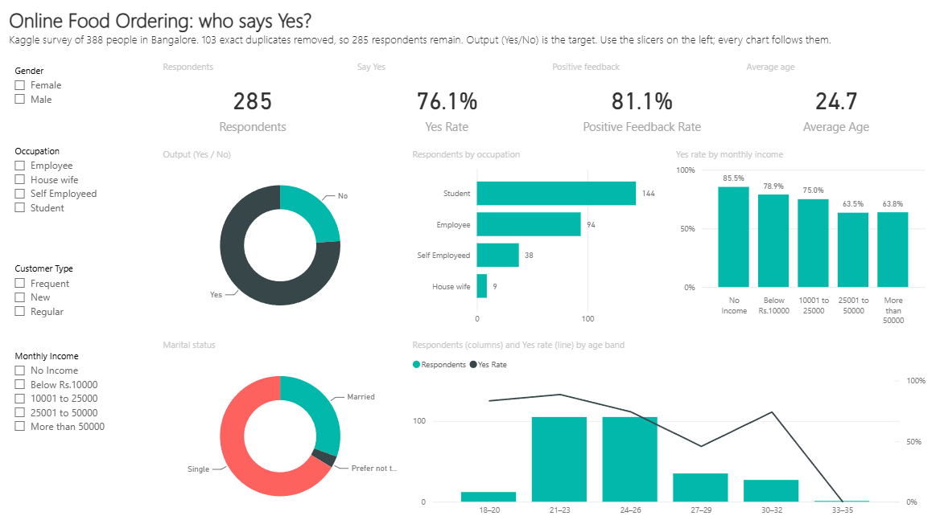
Figure 1: Page 1, Dataset overview
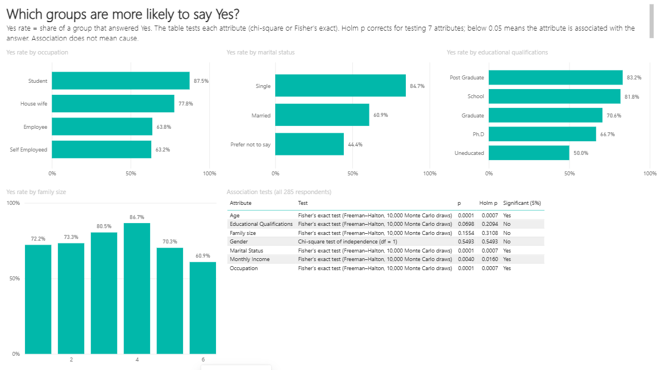
Figure 2: Page 2, Who says Yes
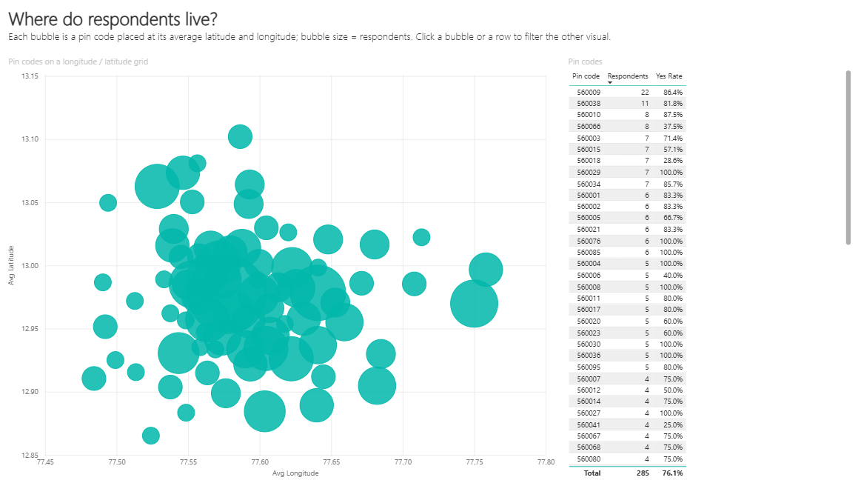
Figure 3: Page 3, Geography
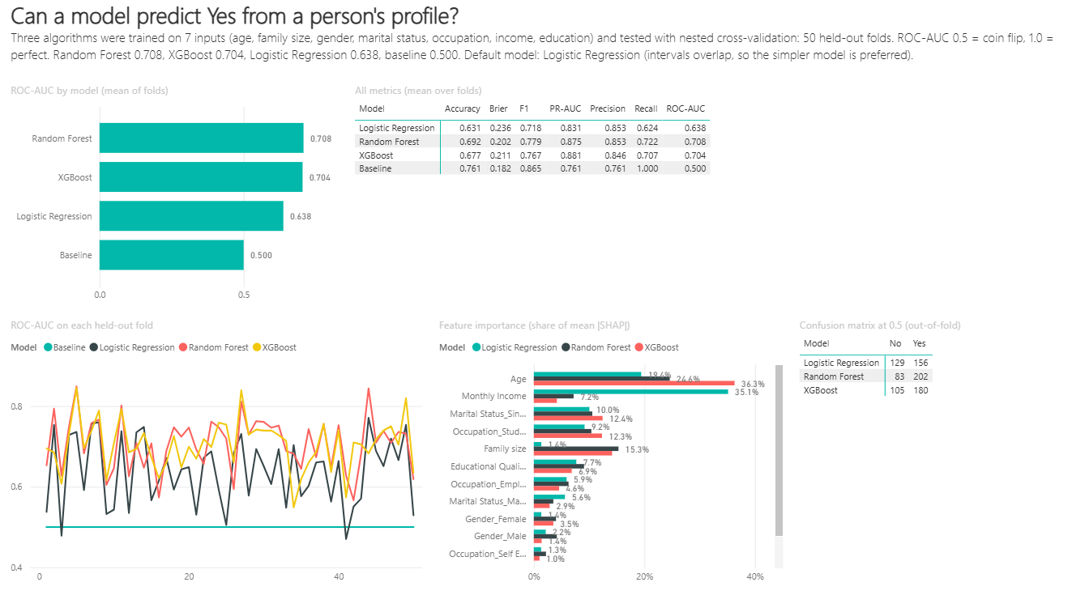
Figure 4: Page 4, Model results
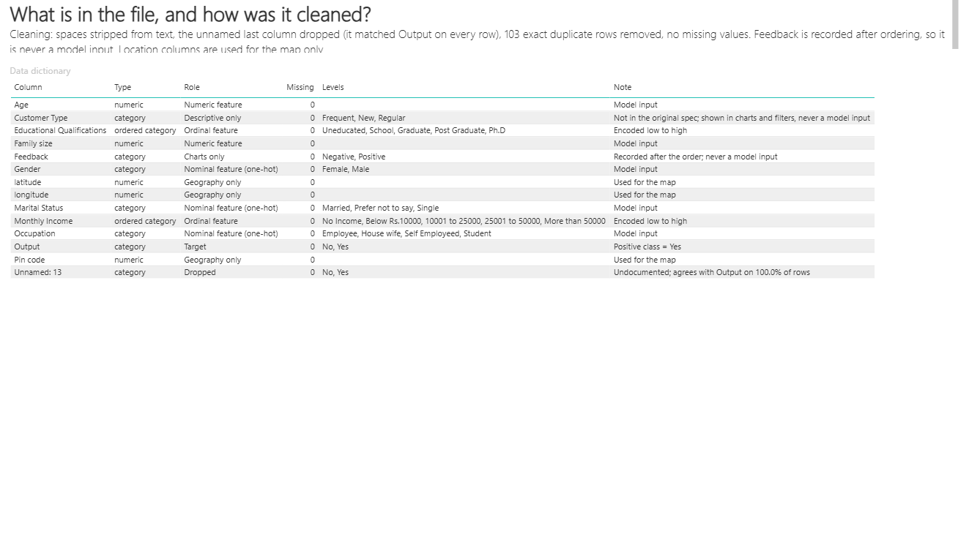
Figure 5: Page 5, Data dictionary

